Java Collections

Interview Questions

Table of Contents
Collections Fundamentals 1
Internal Implementations 5

Collections Fundamentals

Q1. What does fail-fast mean?
Fail-fast means an iterator immediately throws an exception when it detects that the underlying collection has been structurally modified while it is being iterated, instead of continuing with potentially inconsistent data.
In Java collections, this usually results in a ConcurrentModificationException.
public static void main(String args[]){
List<Integer> list = new ArrayList<>();
list.add(10);
list.add(20);
list.add(30);
for (Integer n : list) {
list.add(40); // Structural modification - ConcurrentModificationException
}
}
When we use Iterator for iteration, it does not fail as Iterator.remove() is safe because the iterator itself performs the modification.
public static void main(String args[]){
List<Integer> list = new ArrayList<>(Arrays.asList(10,20,30));
Iterator<Integer> it = list.iterator();
while (it.hasNext()) {
Integer value = it.next();
if (value == 20) {
it.remove(); // Safe
}
}
System.out.println(list); //[10.30]
}

Q2. Difference between ArrayList vs LinkedList.
ArrayList is backed by a dynamic array, while LinkedList is backed by a doubly linked list. ArrayList provides fast random access, while LinkedList is better suited for frequent insertions or removals when you already have a reference to the position
 | ArrayList | LinkedList
Internal structure | Dynamic array | Doubly linked list
get(index) | O(1) | O(n)
Add at end | O(1) amortized | O(1)
Add/remove at beginning | O(n) | O(1)
Insert/remove in middle | O(n) | O(n) to locate + O(1) to modify
Memory | Lower | Higher
Cache locality | Better | Worse
Random access | Excellent | Poor

Q2. Difference between Comparable and Comparator.
Comparable is used to define the natural/default ordering of objects inside the class itself, while Comparator is used to define custom/external ordering separately from the class.

Comparable:
class Employee implements Comparable<Employee> {
int salary;
@Override
public int compareTo(Employee other) {
return Integer.compare(this.salary, other.salary);
}
}

Collections.sort(employees); uses natural ordering, compare by salary.

Comparator:
Comparator<Employee> byName =
(e1, e2) -> e1.name.compareTo(e2.name);
employees.sort(byName);

Can create multiple new compartors to do sorting by any logic.
 | Comparable | Comparator
Package | java.lang | java.util
Method | compareTo() | compare()
Defined | Inside the class | Separate class/lambda
Ordering | Natural/default | Custom/multiple orderings
Multiple sorting strategies | Difficult | Easy

Q3. What happens if duplicate keys are inserted into a Map?
A Map cannot have duplicate keys. If you insert a value using an existing key, the new value replaces the old value.
Map<String, Integer> map = new HashMap<>();
map.put("Alice", 100);
map.put("Alice", 200);
System.out.println(map);
Output: {Alice=200}
The second put() overwrites the previous value.

Q4. Difference between Iterator and ListIterator.
Iterator is a general-purpose iterator used to traverse any Collection, while ListIterator is specifically designed for List implementations and provides bidirectional traversal and modification capabilities.

 | Iterator | ListIterator
Works with | Any Collection | Only List
Direction | Forward only | Forward + backward
next() | ✅ | ✅
previous() | ❌ | ✅
remove() | ✅ | ✅
add() | ❌ | ✅
set() | ❌ | ✅
Index information | ❌ | ✅ nextIndex(), previousIndex()

Iterator:
Iterator<Integer> it = list.iterator();
while (it.hasNext()) {
System.out.println(it.next());
}

ListIterator:
List<Integer> list = new ArrayList<>(Arrays.asList(10,20,30));
ListIterator<Integer> it = list.listIterator();
while (it.hasNext()) {
System.out.print(it.next() + " "); //print value and move to next
} //10,20,30
System.out.println(it.previous());//30
System.out.println(it.previous());//20
}

Internal Implementations

Q1. How Hashmap is implemented internally in java?
A HashMap<K, V> is part of the Java Collections Framework and stores key-value pairs. It allows one null key and multiple null values, and does not maintain insertion order (use LinkedHashMap for that).

Internally, a HashMap uses:
- An array of buckets (Node<K,V>[] table)
- Each bucket is a linked list or tree (in Java 8+)
- Each entry (Map.Entry) contains: Key, Value, Hash, Pointer to next node
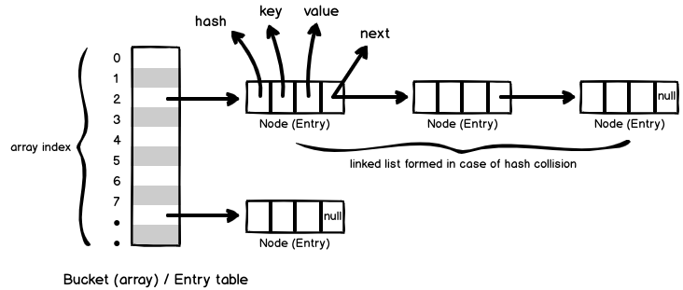

➕ put(K key, V value)
- Compute the hash of the key.
- Find the index (bucket) using: index = (n - 1) & hash;
- If bucket is empty, insert the node.
- If not:
- Search for the key in the linked list.
- If found, update value.
- If not found, append node to list.
- If the list exceeds a threshold (8), convert to a tree.

How hash code is generated: To get hashcode for Pal: System.out.println("Pal".hashCode());
hash = s[0]*31ⁿ⁻¹ + s[1]*31ⁿ⁻² + ... + s[n-1]
For "Pal": 'P' = ASCII 80 , 'a' = ASCII 97, 'l' = ASCII 108
hash = 'P' * 31² + 'a' * 31¹ + 'l' * 31⁰
= 80 * 961 + 97 * 31 + 108
= 79995
What happens if all keys have the same hash? All entries go into the same bucket → poor performance → linked list becomes tree after threshold.

How collision handled here: If multiple entries hash to the same bucket index, they are stored in a linked list at that index.
Eg: Now here for “Pal” and “lap” I will get same index, so what value I will get by calling map.get()
Even if "Pal" and "Lap" land in the same bucket index due to hash collision, Java doesn’t just return the first key it finds.
It performs a two-step lookup:
- Search for index: index = (n - 1) & hash("Pal");
- Search the Bucket’s Entries Using .equals()
if (node.hash == key.hashCode() && node.key.equals("Pal")) {
return node.value;
}

